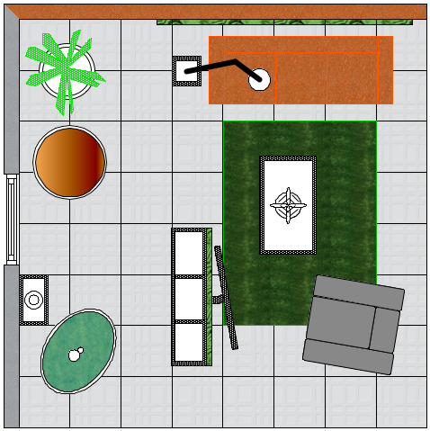

meadow 45.7 x 45.7

grid here taking palce of a rug/ acts as a rug!

snow white grid 50cm x 50cm